SESSION 9: BUSINESS RULES & SYSTEM INTEGRATION

THE REAL-WORLD PROBLEM

A bank launched a new loan app. Technically perfect. Day 1: 500 loan applications approved for criminals. Why? The developers built exactly what was asked: 'Check credit score > 700.' But nobody told them the BUSINESS RULES:

- Rule 1: If criminal record exists → Auto-reject
- Rule 2: If unemployed > 6 months → Manual review
- Rule 3: If age < 21 → Parent co-signer required

Lesson: Requirements tell WHAT to build. Business Rules tell HOW it should work.

PART 2: BUSINESS RULES CATALOG

What Are Business Rules?
Simple Definition: The IF-THEN logic that runs your business.

BUSINESS RULES (Logic/Decisions):
1. "IF customer order > $1000 THEN require manager approval"
2. "IF payment is 30 days late THEN charge 5% late fee"
3. "IF employee works overtime THEN pay 1.5x hourly rate"

NOT BUSINESS RULES (requirements):
1. "System shall process payments" (Functionality)
2. "Page load time < 2 seconds" (Performance)
3. "User can search by customer name" (Feature)

How to Discover Business Rules:
1. "What happens when... [scenario]?"
2. "Are there any exceptions to this rule?"
3. "Who can override this? When?"
4. "What data determines this decision?"

Live Example: E-commerce Discount Rules
1. "IF cart total > $100 THEN apply 10% discount” (Rule 1)
2. "IF user is premium member THEN apply 15% discount" (Rule 2)
3. "Rule 2 overrides Rule 1" (Rule priority)
4. "IF sale item in cart THEN no additional discounts" (Exception)

Business Rules Catalog Template:
Rule ID: BR-001
Name: Premium Member Discount
Description: Premium members get higher discount
Condition: IF customer_type = "premium"
Action: THEN apply_discount = 15%
Priority: 1 (Highest)
Source: Marketing Policy v2.1
Status: Active
Exceptions: Does not apply to clearance items

Exercise
coffee shop. What's ONE business rule they follow?"
(Answers: "Buy 10 coffees, get 1 free", "No refunds after 30 minutes", etc.)

PART 3: DECISION TABLES & TREES

The Problem with "IF-THEN" Lists:
"When you have 5 conditions, you need 32 test cases. Decision tables organize the chaos."

Step 1: Identify Conditions & Actions
CONDITIONS:
1. Credit Score (Good/Bad)
2. Employment Status (Employed/Unemployed)
3. Loan Amount (<$10K/>$10K)

ACTIONS:
A. Auto-approve
B. Manual review
C. Auto-reject

Step 2: Build Decision Table (Whiteboard)

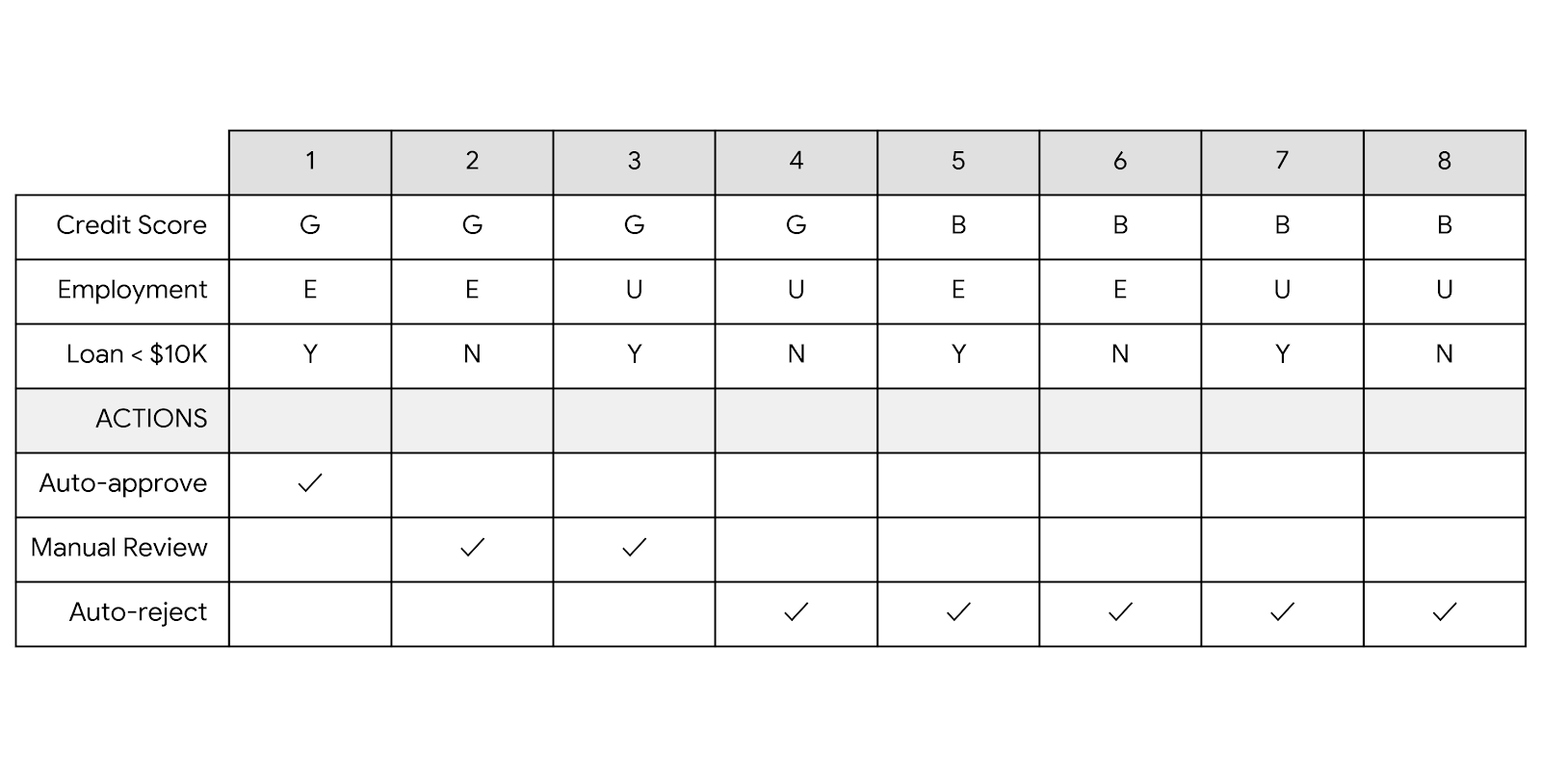Step 3: Translate to Business Rules:
- "Rule 1: IF credit=Good AND employed AND loan<$10K THEN auto-approve"
- "Rule 2: IF credit=Good AND employed AND loan>$10K THEN manual review"

Decision Trees - Visual Alternative

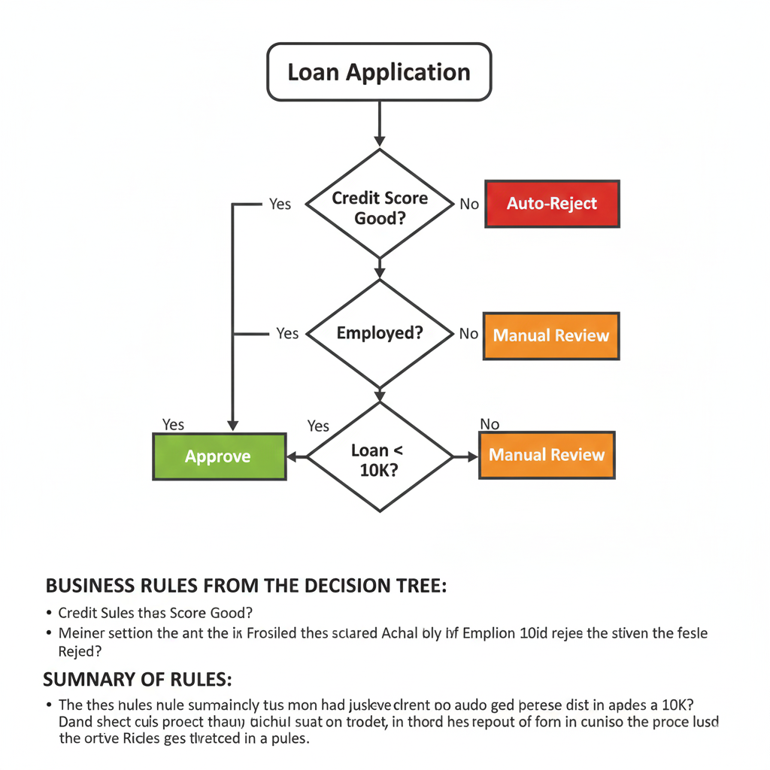
Exercise: Insurance Premium Calculator
Scenario: "Calculate car insurance premium"
Conditions:
1. Age (<25, 25-60, >60)
2. Driving Experience (<2 years, 2-5 years, >5 years)
3. Car Type (Sedan, SUV, Sports)
4. Accident History (None, Minor, Major)

Actions:
- Premium Rate (Low, Medium, High, Very High)

Task: Create decision table with at least 5 rules using draw.io or lucid charts

PART 4: API & INTEGRATION BASICS FOR Bas

The "Why" Before the "What":
A retail company had CRM (Salesforce) and ERP (SAP). Sales closed deal in CRM. Finance couldn't see it in SAP. Warehouse didn't know to ship. Customer waited 2 weeks. Why? No integration.

What is an API? (Simple Analogy)
Think of an API as a Restaurant:
- You (System A): Customer
-Menu (API Documentation): What you can order
- Waiter (API): Takes your order to kitchen
- Kitchen (System B): Prepares your food
- Food (Data): What you receive back

API Types Explained:
1. REST API (Most Common) - Like ordering pizza online:
- Standard menu (endpoints)
- Clear options (parameters)
- Fast delivery (JSON response) HTTP JSON

2. SOAP API (Older) - Like faxing an order form: BANK XML
- Very formal (XML)
- Lots of paperwork (WSDL)
- But very reliable

3. Webhook - Like a notification service:
- Call me when pizza is ready
- System B pushes data to System A
- Real-time updates

Integration Patterns BAs Must Know:

Pattern 1: Point-to-Point (Spaghetti)
CRM → ERP
CRM → Email System
CRM → Analytics

Problem: 10 systems = 45 connections

Pattern 2: Middleware/ESB (Chef)

[Middleware]
↗ ↑ ↖
CRM ERP Email Analytics

Better: One chef manages all recipes

BA Role in Integration: The Integration Requirements

What BAs Specify (NOT how to code it):
1. WHAT data needs to move? (Customer name, order amount)
2. WHEN should it move? (Real-time? Nightly batch?)
3. WHERE from/to? (CRM field X → ERP field Y)
4. HOW OFTEN? (Every order? Daily summary?)
5. WHAT IF it fails? (Retry? Alert? Manual fix?)

Live Demo: Postman for BAs

PART 5: INTERFACE ANALYSIS

What is Interface Analysis?
Studying WHERE systems touch each other.

Three Types of Interfaces:
1. System-to-System (API)
- CRM ↔ ERP
- Payment Gateway ↔ Bank
- BA Focus: Data mapping, error handling

2. Human-to-System (UI)
- User ↔ Website
- Employee ↔ Internal Portal
- BA Focus: Usability, workflow

3. System-to-Human (Notifications)
- System → Email/SMS to user
- BA Focus: Content, timing, triggers

Interface Specification Template:
Interface ID: INT-001
Name: CRM to ERP Customer Sync
Source: Salesforce (CRM)
Target: SAP (ERP)
Frequency: Real-time (on customer update)
Data Fields:
- Salesforce.Field → SAP.Field
- Account.Name → CUSTOMER.NAME
- Account.Email → CUSTOMER.EMAIL
Error Handling:
- Retry: 3 times, 5 minute intervals
- Alert: Email to support@company.com
- Fallback: Manual sync tool available

Live Example: CRM-ERP Integration
Scenario: When salesperson updates opportunity in CRM, update sales order in ERP

We Build Together:
1. Trigger: Opportunity status changes to "Closed Won"
2. Data to Send:
- Opportunity ID
- Customer Details
- Product List
- Pricing
3. Success Criteria: ERP returns "Order Created" confirmation
4. Failure Handling: CRM shows "Sync Failed - Contact IT"

PART 6: NON-FUNCTIONAL REQUIREMENTS

App launched. Worked perfectly... for 10 users. 1000 users tried to login → Crash. Why? No non-functional requirements specified.

Categories with Examples:

1. Performance:
- "System shall handle 100 concurrent users"
- "Page load < 3 seconds on 4G connection"
- "Search results in < 2 seconds for 10M records"

2. Security:-
-"Passwords encrypted (AES-256)"
- "Session timeout after 15 minutes inactivity"
- "API calls require authentication token"

3. Availability:
- "99.9% uptime (≤ 8.76 hours downtime/year)"
- "Maintenance window: Sunday 2-4 AM"
- "Disaster recovery: RTO 4 hours, RPO 1 hour"

4. Scalability:
- "Support 50% user growth without redesign"
- "Add servers without code changes"

5. Compliance:
- "GDPR: Right to be forgotten"
- "HIPAA: Encrypt health data"
- "PCI DSS: Secure payment processing"

How to Elicit NFRs:
- "How many users? Now? In 2 years?"
- "What's acceptable downtime?"
- "Any legal/regulatory requirements?"
- "What happens during peak load?"

PART 7: PRACTICAL EXERCISE – SMART RIDE (END-TO-END CASE)

Scenario: SmartRide (Ride-Hailing Platform)
Systems involved:
- Rider Mobile App (Customers)
- Driver Mobile App (Drivers)
- Ride Engine (Core system)
- Payment Gateway
- Notification Service (SMS/Push)
Current Situation:
- Business rules handled manually or inconsistently
- Surge pricing complaints
- Ride cancellations causing disputes
- Payment & notification mismatches
Problem Statement:
A rider books a trip during peak hours. Fare shown is wrong, driver cancels, payment gets blocked, and the customer complains. Root cause: unclear rules, decisions, and integrations.

Exercise 1: Business Rules Catalog (Connected to PART 1 & 2)
Identify and document core SmartRide business rules:
1️ IF driver rating < 3.5
→ THEN driver cannot accept new rides
2️ IF demand > supply by 2x
→ THEN apply surge pricing
3️ IF rider has 3 unpaid rides
→ THEN disable cash payment
4️ IF rider cancels after driver arrival
→ THEN apply cancellation fee
5️ IF ride booked after 10 PM AND rider is female
→ THEN enable live tracking + SOS

Exercise 2: Decision Table – Surge Pricing Logic (PART 3)

Conditions
- Demand–Supply Ratio (≤1, 1–2, >2)
- Time Slot (Normal / Peak)
- City Type (Metro / Non-Metro)

Actions
- No Surge
- 1.2x Surge
- 1.5x Surge
- 2x Surge

Sample Decision Table (Explain & Draw)
Rule | Demand–Supply | Time | City | Action
R1 | ≤1 | Any | Any | No Surge
R2 | 1–2 | Peak | Metro | 1.5x
R3 | >2 | Peak | Metro | 2x
R4 | >2 | Normal | Non-Metro | 1.2x
R5 | 1–2 | Normal | Any | 1.2x

Exercise 3: Decision Tree – Ride Cancellation (PART 3)
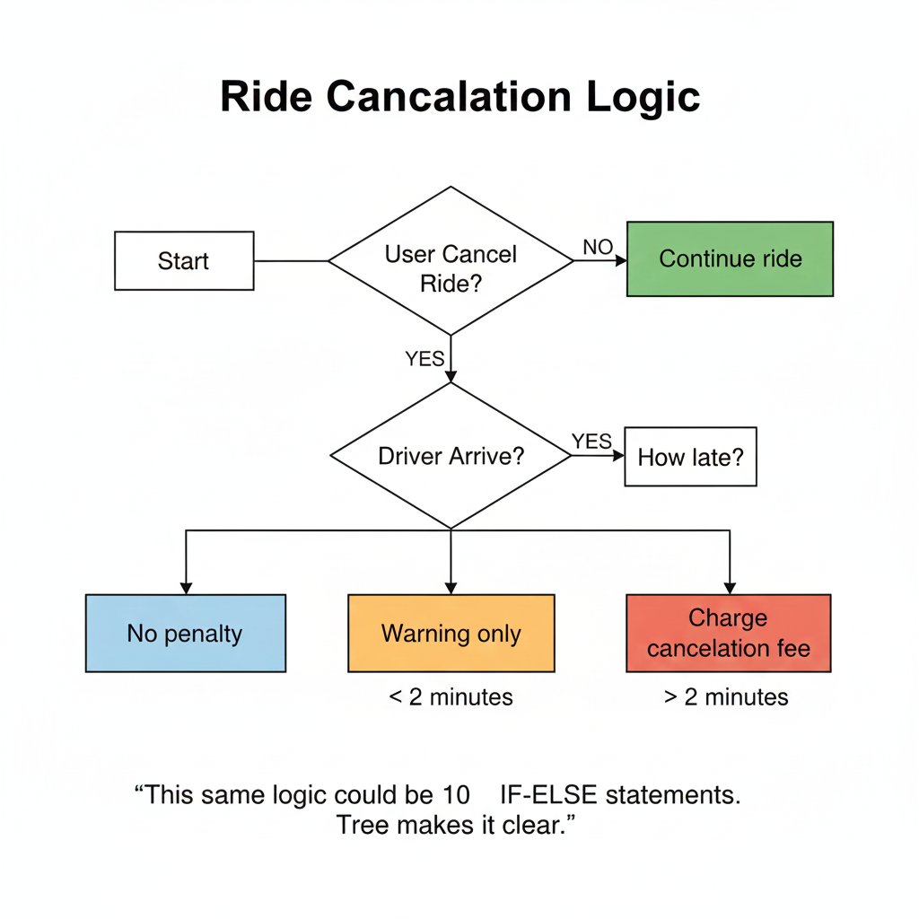

Exercise 4: Interface Analysis (PART 5)

Key Interfaces
1️ Rider App ↔ Ride Engine (API)
- Ride booking request
- Fare calculation
2️ Ride Engine ↔ Driver App
- Ride assignment
- Status updates
3️ Ride Engine → Notification Service
- Booking confirmation
- Driver arrival alerts

Interface Specification Example
Interface ID: INT-SR-01
Name: Ride Booking Interface
Source: Rider App
Target: Ride Engine
Frequency: Real-time
Data Fields:
- Pickup_Location
- Drop_Location
- Rider_ID
- Payment_Mode
Error Handling:
- Retry: 3 times
- Alert user if booking fails
- Allow manual retry

Exercise 5: Integration Requirements (PART 4)

Trigger Events
1️ Ride booked 2️ Ride started 3️ Ride completed 4️ Ride cancelled

Data Mapping
Ride_ID → Payment.Ref_ID
Final_Fare → Payment.Amount
Ride_Status → Notification.Template

Failure Handling
- Payment failure → Retry + notify rider
- Notification failure → Log & resend

Exercise 6: Non-Functional Requirements (PART 6)

Performance
- Fare calculation < 2 seconds
- Ride matching < 5 seconds

Availability
- 99.95% uptime
- No downtime during peak hours

Security
- Mask rider & driver phone numbers
- Encrypt payment data in transit

Scalability
- Handle 10x ride volume during festivals

PART 8: LIVE TOOL DEMO - POSTMAN

PART 9: KEY TAKEAWAYS

1. Business Rules Catalog: The "business logic" bible
2. Decision Tables: Organize complex logic
3. API Understanding: Speak developer language
4. Interface Specs: Blueprint for connections
5. NFRs: Don't forget performance/security!
—----
1. What BUSINESS RULES govern this integration?
2. What DATA needs to move?
3. What happens when it FAILS?
4. How will we know it's WORKING?"

Assignment: Online Food Delivery Integration

Scenario:
- Restaurant has own ordering system
- Partners with UberEats, DoorDash, Zomato
- Needs to sync: Menu, Orders, Status

Tasks:
1. List 5 business rules for order validation
2. Create decision table for delivery assignment
3. Design integration requirements for ONE partner
4. Specify 3 non-functional requirements

1. Postman (API Demo) - FREE
- Why: Shows API testing visually
- GET https://jsonplaceholder.typicode.com/users/1
- APIs are just URLs that return data
2. Draw.io / Diagrams.net - FREE
- Why: Create decision tables/trees visually
- Decision tree for loan approval
- Visual logic is clearer than text
3. Excel/Google Sheets - FREE
- Why: Business rules catalog, decision tables
- Filtering, conditional formatting for rules
- Spreadsheets organize business logic
4. Lucidchart (Free Tier) - FREE
- Why: Professional diagrams, collaboration
- Swimlane + decision tree combo
- Professional tools for real work

postmen example

API TO TEST (GET)
URL
https://jsonplaceholder.typicode.com/users

STEPS TO TEST ONE API IN POSTMAN
- Open Postman
- Click on New → HTTP Request
- In the method dropdown, select GET
- In the request URL field, paste:
https://jsonplaceholder.typicode.com/users
- Do not add anything in:
  - Params
  - Authorization
  - Headers
  - Body
- Click the Send button

EXPECTED RESULT
- Status Code should be:
200 OK
- Response Body should be:
  - JSON format
  - List of users with fields like id, name, email
- Response Time:
  - Any value in milliseconds (example: 100–300 ms)

HOW TO CONFIRM API IS WORKING
- Status code is 200
- Response body is not empty
- Data is in JSON format

Below is another single API with only steps, clean and simple.

API TO TEST (POST)
URL
https://jsonplaceholder.typicode.com/posts

STEPS TO TEST ONE API IN POSTMAN
- Open Postman
- Click New → HTTP Request
- Select POST from method dropdown
- Paste this URL in request field:
https://jsonplaceholder.typicode.com/posts
- Go to Headers tab
Add:
  - Key: Content-Type
  - Value: application/json
- Go to Body tab
Select raw
Select JSON
- Paste this JSON:
{
"title": "Postman Test",
"body": "Testing POST API",
"userId": 1
}
- Click Send

EXPECTED RESULT
- Status Code:
201 Created
- Response Body:
  - Same JSON data
  - New id value returned
- Response Time:
  - Displayed in milliseconds

HOW TO CONFIRM API IS WORKING
- Status code is 201
- Response contains id
- Response is JSON format

